Aesop’s Fable: The Ant and the Dove

Ant: 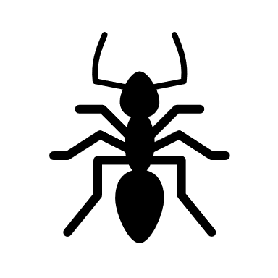 Dove: 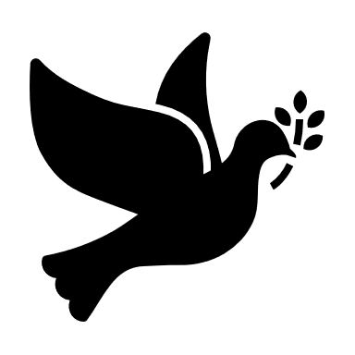

An ant went to the bank of a river to have a drink. The ant fell into the river. The ant nearly drowned. A dove was sitting on a tree by the water. The dove saw what was happening. The dove picked a leaf from the tree and let it fall into the river close to the ant.
The ant climbed onto the leaf. The leaf and the ant floated to safety on the bank of the river.

Later that day a man came and stood under the tree. He wanted to catch the dove. He started to put out twigs covered in sticky glue. He hoped that the dove would get stuck to the twigs. Then the dove would not be able to fly away and the man would catch it.
The ant saw what the man was doing. The ant did not want the man to catch the dove. So, the ant stung the man on the foot. The sting was very painful. The man screamed and threw the sticky twigs into the river. The twigs could do no harm in the river. The noise made the dove fly away. The man did not catch the dove.

Aesop’s Fable: The Ant and the Dove
VOCABULARY

an ant – a kind of insect
a dove – a kind of bird
bank of the river – side of the river
to drown – to go under water and die
to float- to lie on the top of water
twigs – very small branches of trees
glue – something that sticks things together
to sting – to push something sharp into the skin
to scream – to yell or shout
harm – difficulty or hurt

Aesop’s Fable: The Ant and the Dove
QUESTIONS

- What kind of insect needed a drink?
- Where did the ant nearly drown?
- What animal saw the ant?
- What did the dove do with the leaf?
- How did the ant get to safety?
- What sort of twigs did the man put out?
- Why did the man put the twigs out?
- What did the ant do to the man?
- Why did the man scream?
- What happened when the man screamed?
- Which of these proverbs is the moral of this story?
- Birds of a feather flock together. Or
- One good turn deserves another.

Answers to: asylumesol@rmcentre.org.uk
Or 07810 408570

