**Corona virus**

1. **Setting the scene.**



Look at this picture.

What do you see in the picture?

1. Match words with pictures

|  |
| --- |
| *a virus paper towels a fever breathing problems a hand gel soap*  *a runny nose a sore throat a GP hug a cough isolate (stay at home)* |

[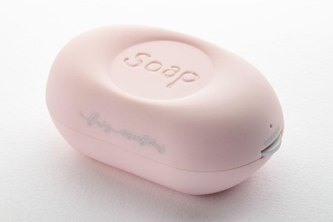](https://www.google.co.uk/url?sa=i&url=https://thepipscafethailand.bentoweb.com/th/mobile/product/535169/product-535169&psig=AOvVaw1OmP1-petXguzqcQTO9Hqe&ust=1583580531199000&source=images&cd=vfe&ved=0CAIQjRxqFwoTCLDCmKnghegCFQAAAAAdAAAAABAE) [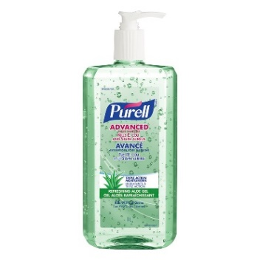](https://www.google.co.uk/url?sa=i&url=https://www.londondrugs.com/purell-advanced-hand-sanitizer-gel---refreshing-aloe---1l/L6637243.html&psig=AOvVaw3exbgasx2ZyED934f-Bq9S&ust=1583580456779000&source=images&cd=vfe&ved=0CAIQjRxqFwoTCMjT0oXghegCFQAAAAAdAAAAABAF) [](https://www.google.co.uk/url?sa=i&url=https://www.health24.com/Medical/Cough/News/7-myths-about-cough-20170508&psig=AOvVaw3G_BSHD7zCh6kk5xPw5jRs&ust=1583580840790000&source=images&cd=vfe&ved=0CAIQjRxqFwoTCPin1LzhhegCFQAAAAAdAAAAABAE)

a…………………………. b…………………………… c………………………..

[](https://www.google.co.uk/url?sa=i&url=https://www.galleonsupplies.co.uk/paper-hand-towels-c19/1-ply-blue-c-fold-paper-hand-towels-p142&psig=AOvVaw3QaHA69ex41vb8CtuNXM_x&ust=1583580585460000&source=images&cd=vfe&ved=0CAIQjRxqFwoTCNCkiMPghegCFQAAAAAdAAAAABAQ) 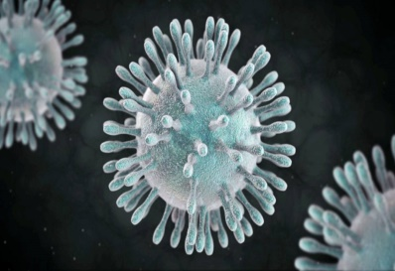 [](https://www.google.co.uk/url?sa=i&url=https://newsnetwork.mayoclinic.org/discussion/home-remedies-fighting-a-fever/&psig=AOvVaw0wqvia5SlKWJrUX2-eABxb&ust=1583580747035000&source=images&cd=vfe&ved=0CAIQjRxqFwoTCNi0-Y_hhegCFQAAAAAdAAAAABAF)

d……………………………. e………………………… f……………………………

[](https://www.google.co.uk/url?sa=i&url=https://thewellnessinsider.sg/2018/04/breathing-difficulties-and-habits-to-help-you-breathe-better/&psig=AOvVaw19Bcqm5nV4muZVrRUzsneS&ust=1583580884132000&source=images&cd=vfe&ved=0CAIQjRxqFwoTCOD5ptHhhegCFQAAAAAdAAAAABAK) 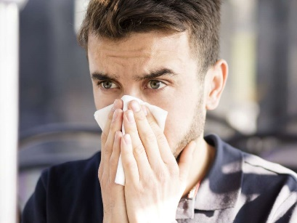 

g…………………………. h…………………………. i…………………………

  

j………………………. K…………………………….. L………………………

1. Pronunciation. Listen and mark the syllables.

*For example: chil/ dren or CHIL / dren*  (2 syllables: ‘chil’ and ‘dren’)

*boy (1 syllable)*

*A virus Soap*

*Paper towels A runny nose*

*A fever A sore throat*

*Breathing problems A GP*

*Hand gel A cough*

*Isolate Hug*

1. What are the 4 *symptoms* of a virus?

a………………………………………..

b………………………………………..

c………………………………………..

d……………………………………….

1. Writing. Finish these sentences using symptoms.

*For example, I have got a sore throat.*

1. *I have got ………………………………*
2. *My wife has ……………………………*
3. *My husband has ……………………….*
4. *My child has* …………………………….
5. *My children have……………………….*
6. *I have to ………………………………..*
7. Match the *verbs* (green) with the *phrases* (orange)

|  |  |
| --- | --- |
| **stay** | your wet hands with a paper towel |
| **touch** | immediately the 111 number |
| **shake** | hand gel |
| **go** | your face |
| **wash** | people’s hands |
| **use** | to the GP |
| **dry** | away from people |
| **phone** | Your hands well |

1. Write the phrases out:

*Stay …………………………………………………………………………………..*

*Touch………………………………………………………………………………....*

*Shake…………………………………………………………………………………*

*Go……………………………………………………………………………………..*

*Wash………………………………………………………………………………….*

*Use……………………………………………………………………………………*

*Dry……………………………………………………………………………………*

*Phone…………………………………………………………………………………*

1. Use the words in the box to make a sentence for the sentences *I must not* (p. 5) and *I must* (p.6):

|  |
| --- |
| *use wash go shake touch dry phone isolate hug* |

*I* ***must not…………………….***

1. [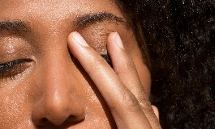](https://www.google.com/url?sa=i&url=https://www.nytimes.com/2020/03/05/health/stop-touching-your-face-coronavirus.html&psig=AOvVaw1eZWMTVvVTyzXhqRzqbZaj&ust=1584005022775000&source=images&cd=vfe&ved=0CAIQjRxqFwoTCIDRwdqNkugCFQAAAAAdAAAAABAE) *I* ***must not*** *……………my face.*

1.  *I* ***must not*** *……………hands.*
2. *I* ***must not*** *……………to the GP’s.*
3. *I* ***must not*** *……………..people.*

*I* ***must…………………………………..***

1. 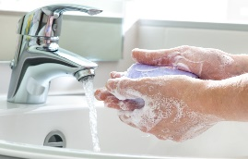 *I* ***must …………….****my hands well.*
2. 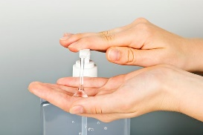 *I* ***must …………….****hand gel.*
3.  *I* ***must …………….****my hands with**paper towels.*
4. [](https://www.google.com/url?sa=i&url=https://unsplash.com/s/photos/woman-on-phone&psig=AOvVaw1i1pramTkvy_Me3FfChPOA&ust=1584015020626000&source=images&cd=vfe&ved=0CAIQjRxqFwoTCPDwkPqykugCFQAAAAAdAAAAABAE) *I* ***must ……………………****the 111 number.*
5. *I* ***must ………………..****and stay at home.*
6. Conversation. Read this conversation between Jane and a GP (doctor):

|  |  |
| --- | --- |
| **GP:** | *Hello, how can I help you?* |
| **Jane:** | *Hello, I have a bad fever.* |
| **GP:** | *Do you have any other symptoms?* |
| **Jane:** | *Yes, breathing problems and a runny nose.* |
| **GP:** | *Okay, go home and phone the 111 number.* |
| **Jane:** | *Anything else?* |
| **GP:** | *Yes, isolate with your family at home and don’t go out for two weeks.* |
| **Jane:** | *Thank you bye.* |
| **GP:** | | *Bye. Look after yourself.* |