Reading: developing reading skills:
Look at this picture and think of these questions:
Are there homeless people in your town or city?
Are there more homeless people than before?
What age are homeless people?
Do you know any homeless people?
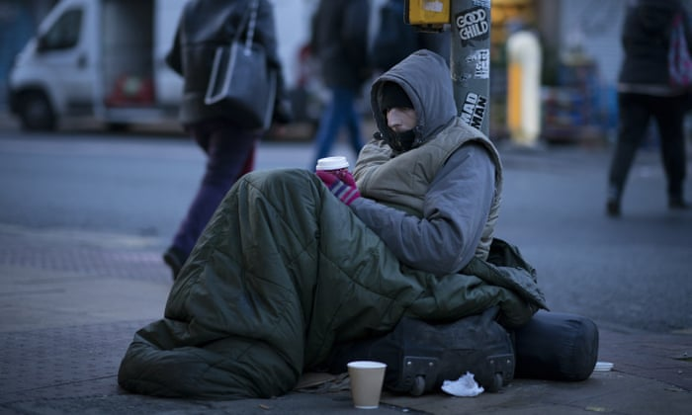

Reading. Homeless up by 65% in 7 years. Read and answer the questions.
(A). Homelessness has rocketed by 65% in the last seven years.

(B). Almost 80,000 families, couples and single people have been housed in temporary accommodation as they have nowhere else to live. The rise from 48,010 in December 2010 was described as ‘nothing short of a tragedy’ by charity Crisis.

(C). The true number of homeless is likely to be considerably higher as the figures do not take account of rough sleepers and ‘sofa surfers’ relying on the kindness of friends.

(D). Crisis chief executive John Sparkes said, “Our continued decline of social housing, welfare cuts and private rents are pushing more and more people into homelessness and unsuitable temporary accommodation. The government must act urgently to stop this trend.”

(E). The number of households living in in temporary accommodation was 79,190 in September, the Department of Communities and Local Government figures show.

(F). Some 132 of the households with children were former residents of fire-ravaged Grenfell Tower or blocks nearby that were put out of action by the blaze in West London.

(G). A national survey last year found there were more than 4000 rough sleepers in England, although charities believe that this is an underestimate.

(H). Councils have a legal duty to house the homeless but only if the meet certain criteria. Single people and childless couples not thought to be vulnerable are excluded, along with asylum-seekers and some people from overseas.

- Match these phrases with the paragraphs. Write the letter of the paragraphs A to H.
The results of a national survey….G.
Homeless relying on the kindness of their friends…….
An increase in homelessness……..
Households being put in temporary accommodation……
The tragedy of temporary accommodation……
Grenfell Block residents still waiting to be re-housed…..
The need for the government to act more……

- Are the statements true () or false (X)?

- There has been a fall in homelessness in the last seven years.

- There are 70,000 families waiting to be re-housed.

- The government figures on homelessness are likely to be correct.

- The residents of Grenfell Towers have been re-housed.

- There are 4000 rough sleepers in England.

- Councils have a duty to re-house all categories of homeless people.

- Find these words in the text and choose the best meaning.

- Rocketed [.] (A)

- A sharp rise
- A sharp fall
- Remaining the same

- Take into account [v.] (C)

- To not count
- To consider when making a judgement
- To remember something when you are not thinking about other things

- Rough sleeper [adj. n.] (C)

- S.o. who sleeps at home
- S.o. who sleeps on something hard
- S.o. who sleeps in the street

- Sofa surfer [adj. n.] (C)

- S.o. who surfs in the sea
- S.o. who surfs the internet
- S.o. who sleeps on a friend’s sofa

- Trend [n.] (D)

- A fashion
- A start
- A danger

- Figures [n.] (C & D)

- Shapes
- Numbers
- Ministers

- Households [n.]

- The number of adults in a family
- The amount of space in a house
- All the people living together in a house or flat

- Ravaged [adj.] (F)

- Destroyed
- Built-up
- Renewed

- Blaze [n.] (F)

- Made
- Burning
- A crowd

- Survey [n.] (G)

- An observation
- An investigation
- Research by asking people questions

- Legal [adj.] (H)

- To do with the government
- To do with culture
- To do with the law

- Duty [n.] (H)

- A tax
- A payment
- Something you must do because it is your job or responsibility

- Underestimate [v.] (G)

- Guess rightly
- Guess wrongly
- Understand well

- Read and answer these questions.

- What rise was there in homelessness in December 2010?
………………………………………………………………..
- Name two categories of people who are not likely to be included in the government figures?

- ………………………………………

- ………………………………………

- Who said the government needs to change the trend?
………………………………………………………

- How many homeless were there in September?
…………………………………………………….

- How many Grenfell Tower residents are still waiting to be accommodated?
………………………………………….

- What are the four categories of people that the government does not need to accommodate?

- …………………………………….
- ……………………………………
- ……………………………………
- ……………………………………

- Use these words for the gap-fill:

duty (n) figures (n) take into account (v) underestimate (v) rocketed (v)

ravaged (v.) legal (n.) household (n.)

- The cost of living has …………………….in the last five years.

- Do not ……………………how much time you need to get to the station.

- The sales ……………… at the clothes shop have been very good this month.

- Although she is very tired, you must …………… that she has to look after four children.

- As a parent, it is your ………….. to make sure your child has a good breakfast in the mornings.

- The man came back from holiday and was …………………….by a disease.

- The government has a ……………………responsibility to provide children’s education.

- There are six people living in my ……………………..

- Affixation. Words can be changed by adding a prefix, a suffix or both.

A prefix is something that goes before a word.

For example, happy unhappy

A suffix goes after a word

For example, happily – notice the change in spelling (‘y’ to ‘i’)
childless

Sometimes we can have both unhappily but not unchildless

Look at these words. Can I add a prefix, a suffix or both? Can you make 7 new words?

Prefix (-un/ -in) | Root word | Suffix (-ness, -ility)
 | sociable
 | kind
 | suitable
 | vulnerable

1…………………………….
2…………………………….
3…………………………….
4……………………………
5……………………………
6……………………………
7……………………………

