Boudica, Queen of the Iceni
Look at these pictures. What words do you know?
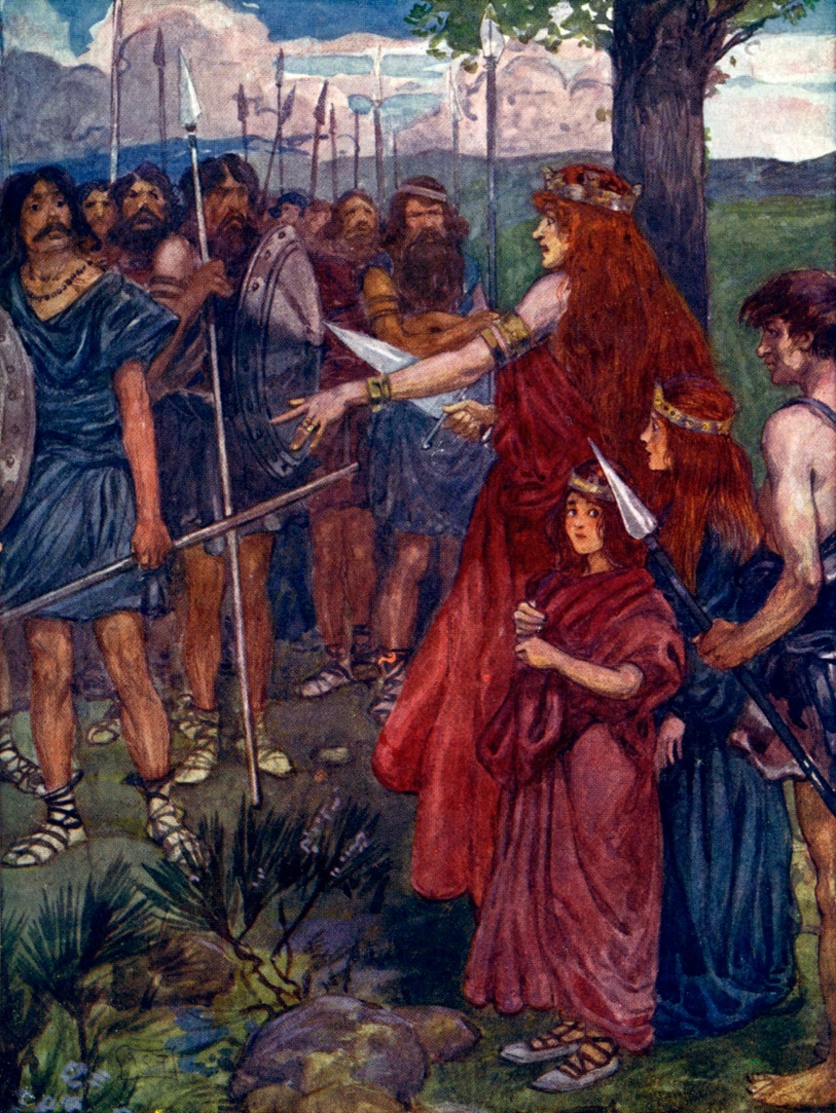

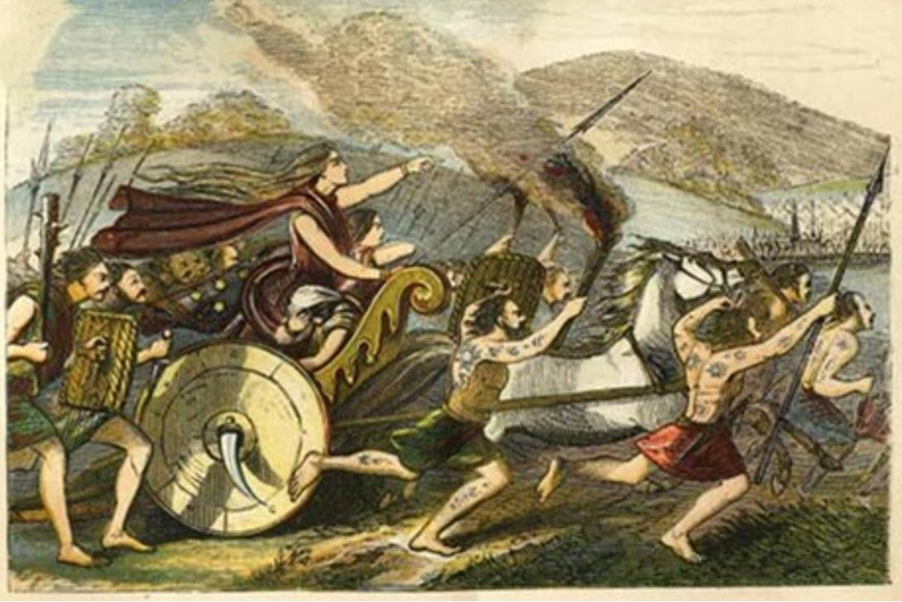

Reading
Boudica was born in 30 A.D. and was the queen of the Iceni tribe who lived in Norfolk (East England) The name Boudica means victory or Victoria. She was a tall woman with long red hair and a harsh voice. [A]

Boudica was married to King Prasutagus and had two daughters. When King Prasutagus died, the Romans said she could not inherit her husband’s lands and they took them from her. They also beat her up and abused her daughters. Boudica was very angry and called up her Iceni army to kill all the Romans in Britain. Boudica and her army first stormed Colchester and killed every person in the city and after, she attacked London and St. Albans. She massacred between 70,000-100,000 Romans in the three cities and burnt all the buildings. [B]

The Romans then sent a big army and defeated Boudica in a big battle in the Midlands. Boudica and her daughters drank poison so they were not captured by the Romans. She died in 60 A.D. Today there is a statue of Boudica at Westminster Bridge in London. [C]

- Read these sentences. Are they true () or false ().

- Queen Boudica was born in 40 A.D.

- Boudica had red hair.

- Boudica never was married.

- She had two daughters.

- Boudica was angry with the Romans because her husband died.

- Her army attacked Colchester, St. Albans and Oxford.

- Boudica and her daughters were killed by the Romans.

- What do these words mean? Read the words in the sentences

- ‘tribe’ (A) [was queen of the Iceni tribe]

- A group of the same people living together
- A group of different people living together
- A group of old people living together

- ‘victory’ (A) [Boudica means victory]

- To lose
- To understand
- To win

- ‘harsh’ (A) [She was a tall woman with long red hair and a harsh voice]

- Loud
- Small
- Ugly, not nice

- ‘inherit’ (B) [she could not inherit form her husband’s lands]

- Money you get when you marry
- Money you get when someone dies
- Money you have to pay the government

- ‘abuse/ abused’ (B) [they beat her up and abused her daughters]

- To put in prison
- To use violence
- To be good to

- ‘army’ (B) [(she) called up her Iceni army]

- A group of men who fight
- A group of men who teach
- A group of men in a family

- ‘storm/ stormed’ (B) [her army first stormed Colchester]

- To attack a place with an army
- To go to a place
- To visit a place

- ‘defeat/ defeated (C) [The Romans sent a big army and defeated Boudica]

- To look for
- To lose
- To win

- ‘battle’ (C) [a big battle in the Midlands]

- A fight between armies
- A road
- A town

- ‘massacre/ massacred’ (C) [She massacred between 70000-100000 Romans]

- To take prisoners
- To kill every person
- To make peace with someone

- ‘poison’ (C) [Boudica and her daughters drank poison]

- A drink with alcohol
- A drink with medicine
- A drink which kills you

- ‘capture/ captured’ (C) [so they were not captured by the Romans]

- To control a place
- To leave a place
- To build a place

- ‘statue’ (C) [Today there is a statue of Boudica]

- A building in stone or metal
- A painting of a person
- A real figure of a person in stone or metal

- Grammar: the past simple tense

- Look at these verbs in the box. Are they regular or irregular past simple verbs?

was lived married had died said could took beat abused

attacked called killed stormed massacred burnt sent defeated

Irregular past simple | Regular past simple
………………………………………………  ………………………………………………  ………………………………………………  ………………………………………………  ………………………………………………  ………………………………………………  ………………………………………………  ………………………………………………  ………………………………………………  ………………………………………………  ……………………………………………… | ……………………………………………  ……………………………………………  ……………………………………………  ……………………………………………  ……………………………………………

- Pronunciation. Look at these verbs in the box. Which ending do they have?
lived married died said abused attacked called killed

stormed massacred burnt defeated

/id/ | /d/ | /t/
……………………………  ……………………………  …………………………… | …………………………..  …………………………..  …………………………..  …………………………. | ……………………………  ……………………………  ……………………………  …………………………….

- Writing.
Write about a hero or heroine from your country. Use past simple tenses form the box below. Writing five sentences.
was born in He/she did he was famous because he died in

……………………………………………………………………………………………………………………………………………………………………………………………………………………………………………………………………………………………………………………………………………………………………………………………………………………………………………………………………………………………..
Corrections:
……………………………………………………………………………………………………………………………………………………………………………………………………………………………………………………………………………………………………………………………………………………………………………………………………………………………………………………………………………………………………………

